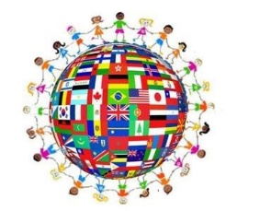

International Night at Crabapple Middle School
March 4th, 2020
5:30-7:00 pm

Please join us this year in helping us create our best International Night yet! This year, we will have 35 countries represented. Each class will be given a specific country this year to work on together. Within the class, there will be different groups (2-4 students) that form committees that will research a certain topic for the given country. Everyone is required to participate in researching and creating the presentation.
Students will be able to pick their groups but will randomly pick their topic. On the night of the presentations, students will sign up for rotations to come and represent their country. Although not mandatory, it is highly encouraged for all students to attend International Night. The idea is for all students and families to learn about other countries and cultures. All world language students will be working hard to make this a successful evening. Your support is encouraged and appreciated. Students are encouraged to bring in authentic artifacts/items for display or to ask a relative to attend as a part of the presentation. Students from each class are asked to bring in typical food from the country to share, either bought or made at home.
While attending I-Night this year, students will be handed a scavenger hunt document to complete with facts about the different countries. Once students have completed the scavenger hunt, they are to turn it in to their teacher in order to be entered into a raffle! (Winners to be determined the following school day.)
We are excited and with your help we know that this will be an amazing event! Below are the expectations from each class and committee.

Thank you.

Crabapple World Language Department

